**OBJECT ORIENTED PROGRAMMING WORK**

**MODULE 6**



**CREATED BY :**

**KURNIAWAN BAGASKARA**

**L200214253**

**INFORMATICS STUDY PROGRAM**

**FACULTY OF COMMUNICATION AND INFORMATION SCIENCE**

**MUHAMMADIYAH SURAKARTA UNIVERSITY**

**1.Create a Vehicle class, which has at least 3 instance variables that have initial values. After that, create Car and Airplane classes, each of which is a subclass of Vehicle.**

**2. From each subclass, there is 1 unique variable that has an initial value, which is not found in the superclass, and 1 variable has an initial value - has the same name as the name of the variable in its superclass. Here's the source code:**

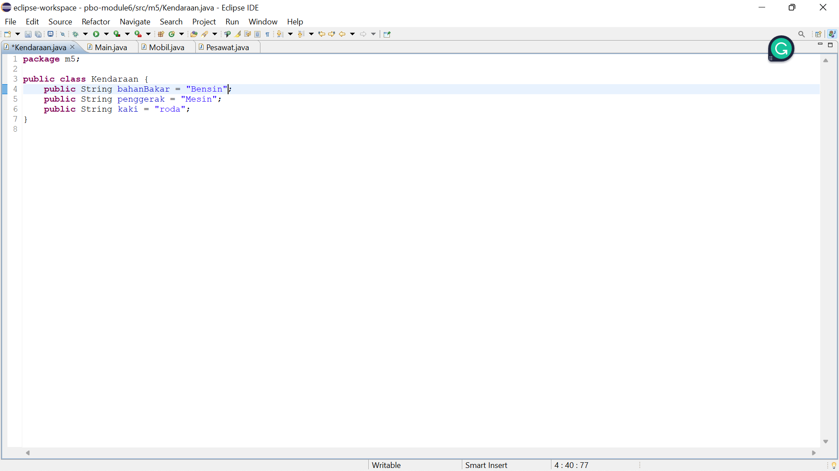

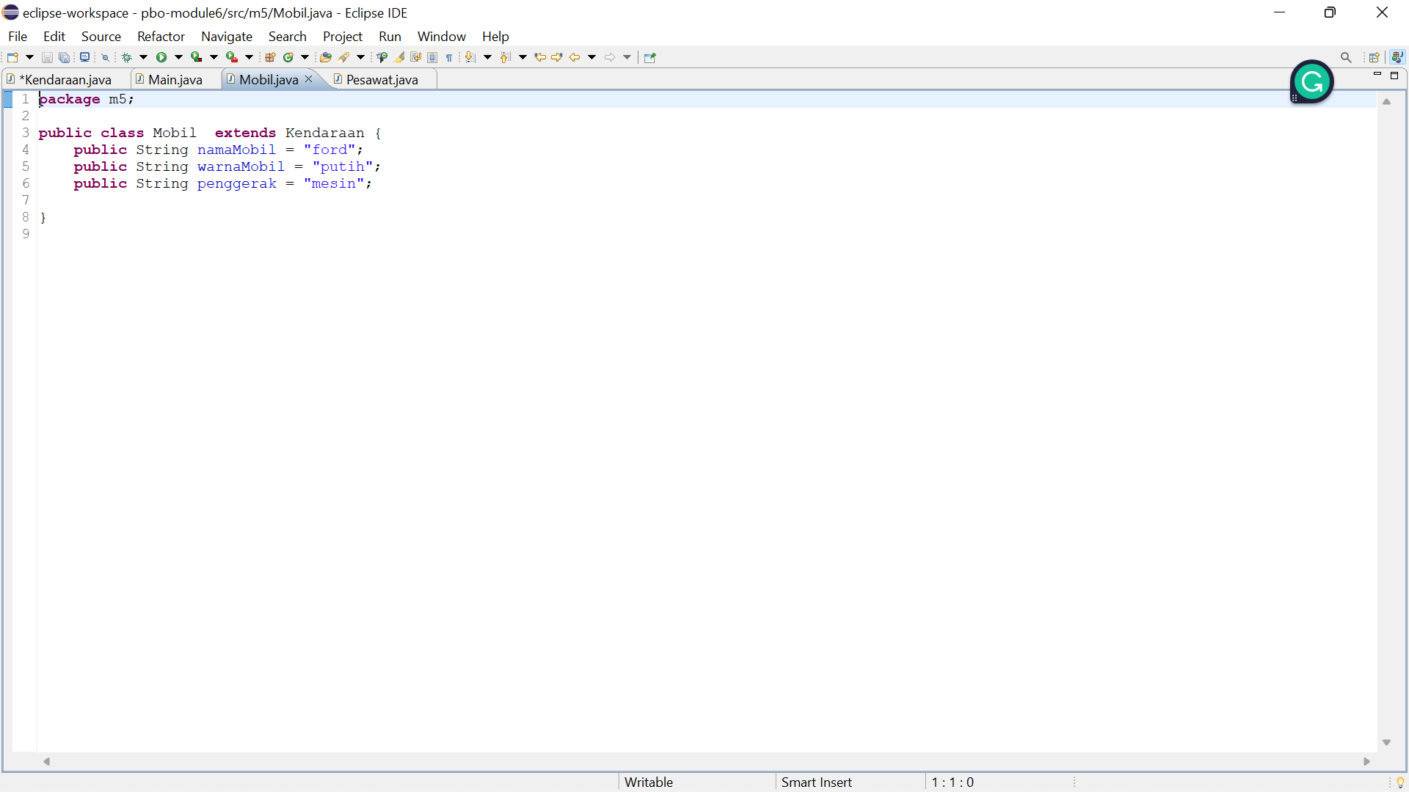

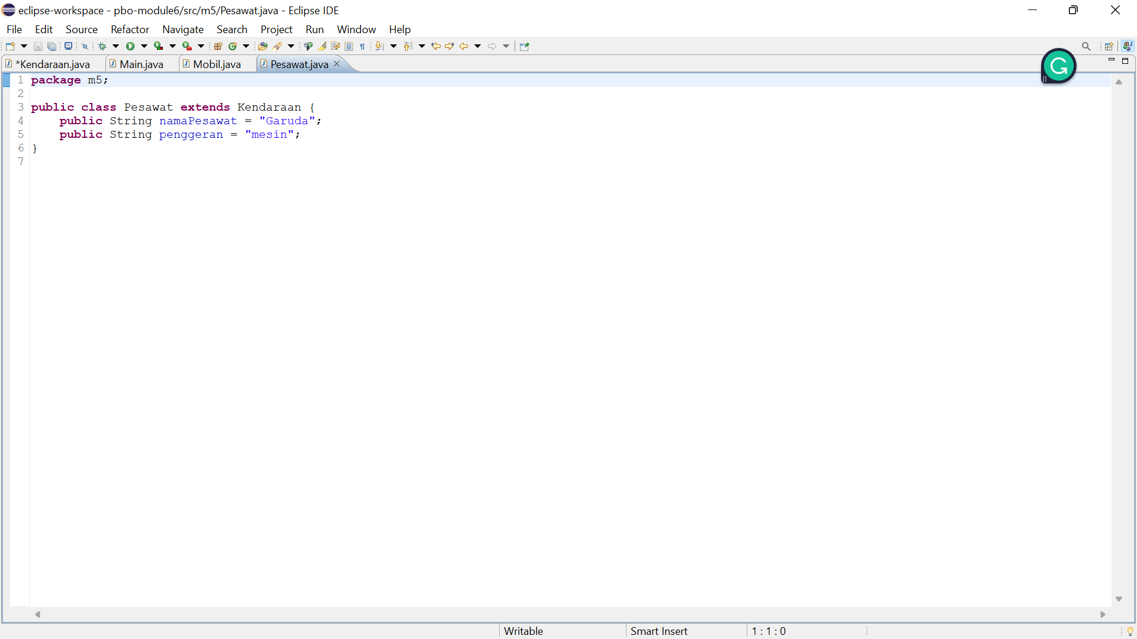

1. **Create a main class to display the results of the code above. The main method will display the values ​​stored in all instance variables contained in the subclass and superclass. Here is the source code and the output:**

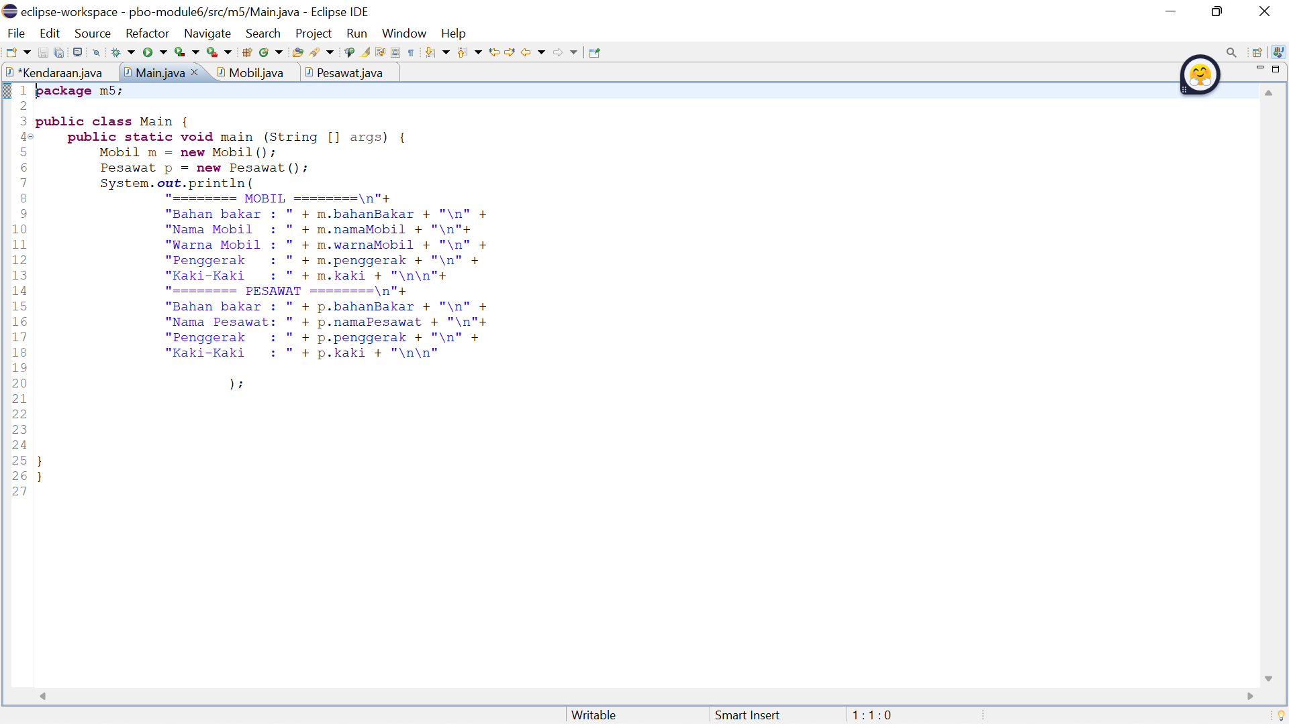

**Output:**

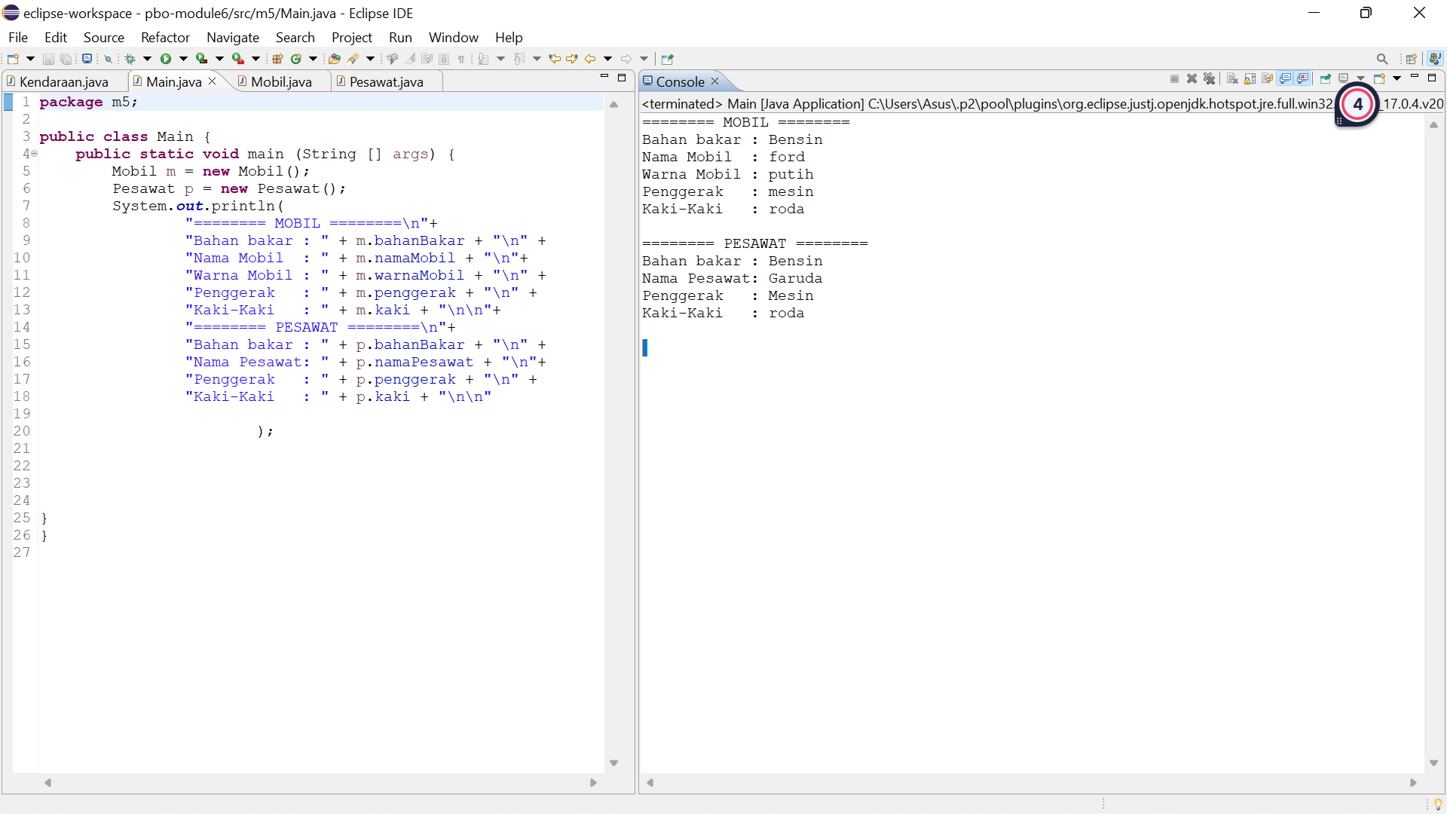

**Task**

**The following is the program code that I made based on Figure 6.3 in the module:**

**Two-dimentional figure**

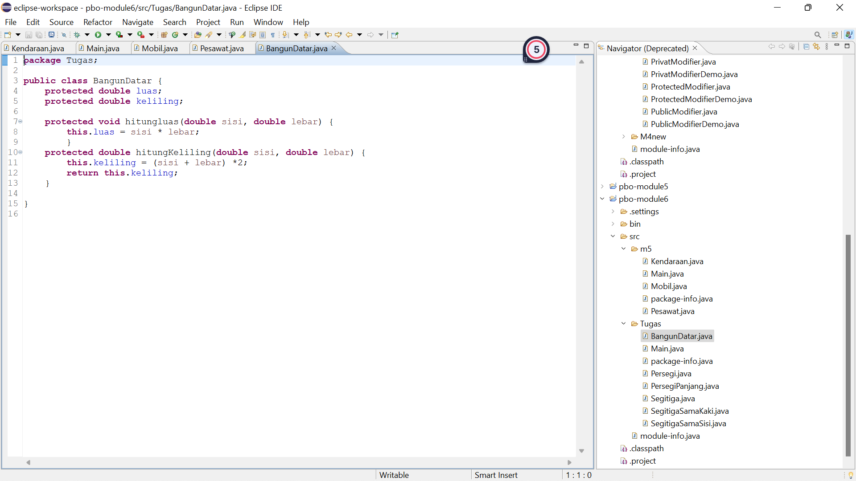

**Rectangle**

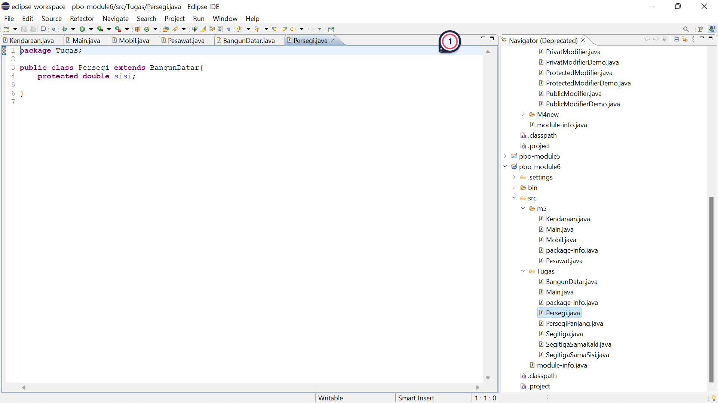

**Rectangular**

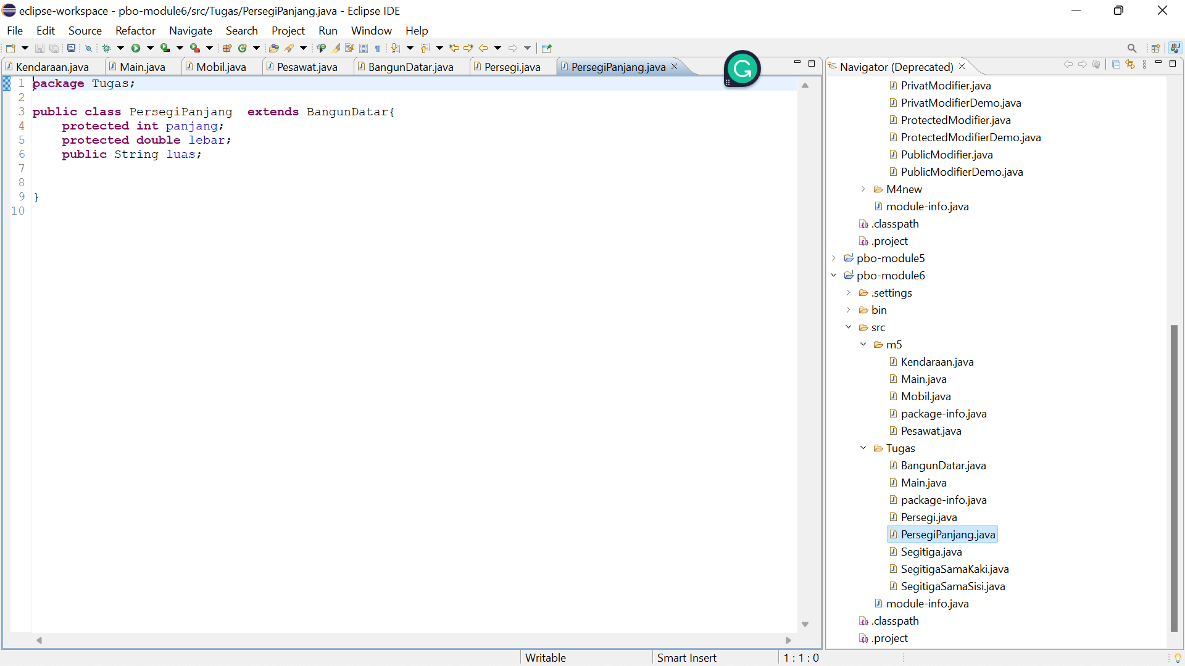

**Triangle**

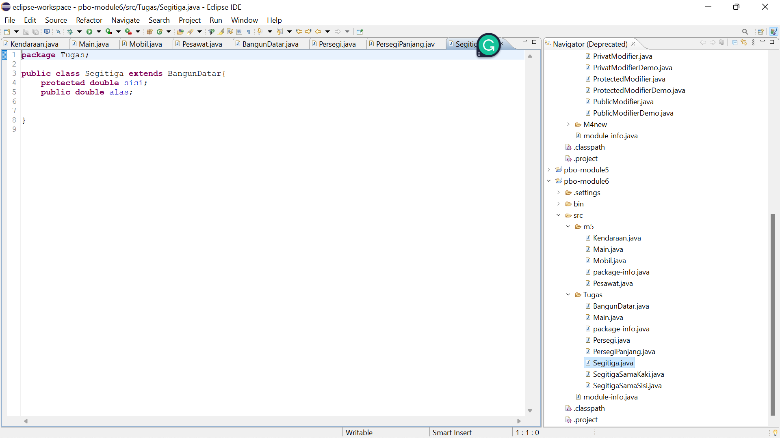

**Equilateral triangle**

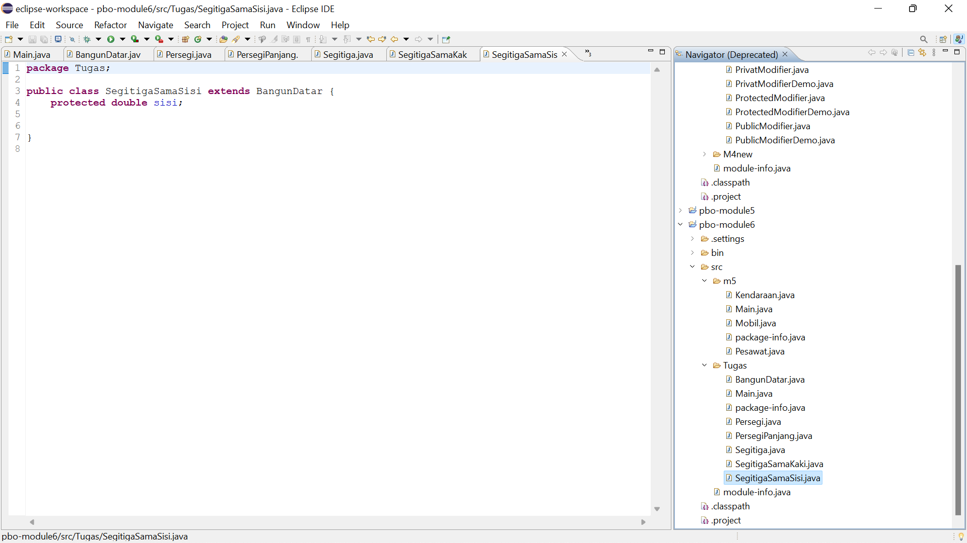

**Isosceles triangle**

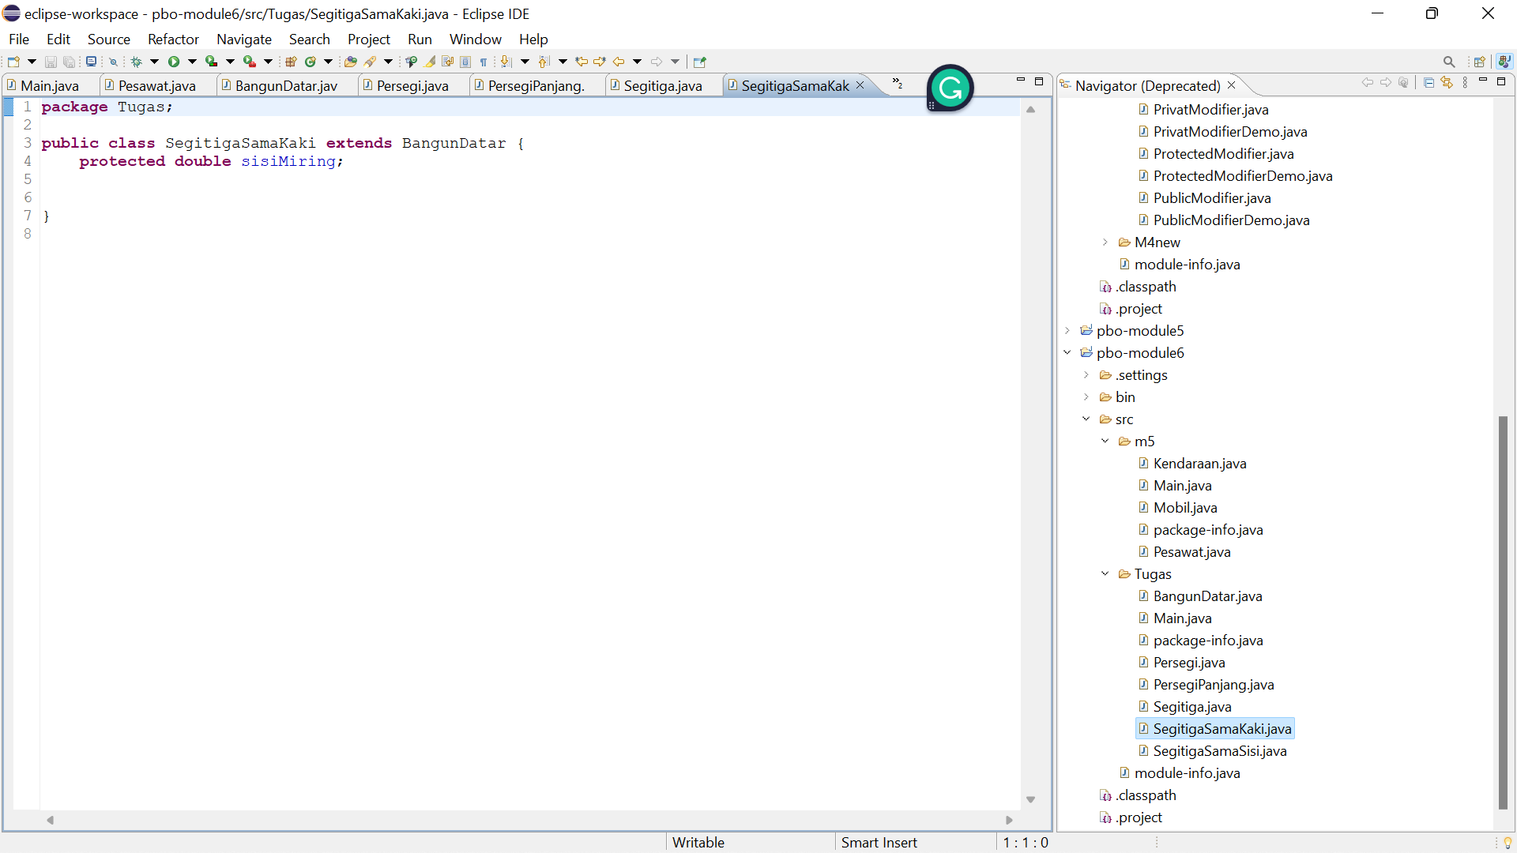

**Main Class**

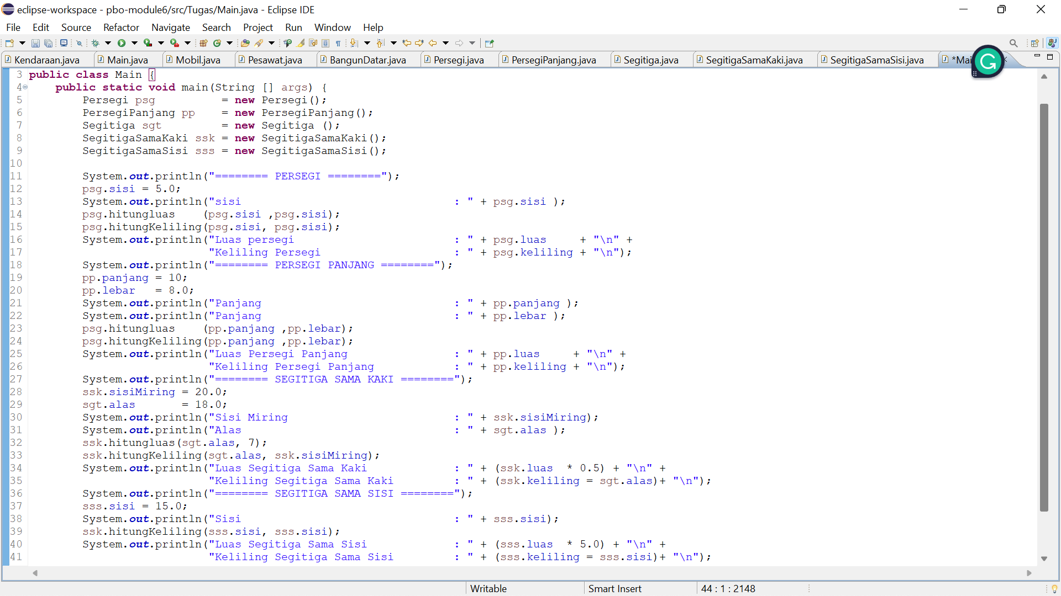

**Output**

